CaPOC – 2005!

DAY 1 - TWIST-O-RAMA
August 20, 2005 – 10:00am to ?????

Starting Point: ARCO Olympic Training Center
2800 Olympic Parkway
Chula Vista, CA

Ending Point: Motel 6
745 E. Street
Chula Vista, CA 91911

Thank you for joining us on the drive portion of the TOR! It is our hope that you will enjoy your ride and have a fun time the remainder of the weekend. Please read the directions below carefully. If you have any questions, please ask.

A few notes first:

- Make sure your car is in good repair. That means all tires are properly inflated and in good condition; that your car has no leaks or other mechanical problems.
- Have plenty of fuel. There will be few gas stops on this cruise, so please make sure that your tank is full before leaving. It is a good idea to have one or two fuel cans in your vehicle in the event you need one.
- Have a small set of tools available in the event you must stop and make a roadside repair.
- Please be courteous on the road. This cruise is meant to be just that, a cruise. There are no ‘points’ or ‘awards’ on this cruise. At NO time should this be considered a race, but it IS NOT A RACE. ANYONE DRIVING RECKLESSLY OR DANGEROUSLY WILL BE ASKED TO LEAVE THE GROUP.
- At NO time should anyone start driving carelessly. This can jeopardize the ENTIRE GROUP, not to mention that it is NOT SAFE and it can result in serious harm or injury to EVERYONE ON THE CRUISE.
- Everyone is encouraged to have an FRS radio WITH sub-channels. They are not that expensive and can be purchased at your local electronics store for less than $50 for a pair.
- No excessive noise. This means please do not blast your radios so that all in the county can hear it. We will be using FRS radios to communicate with one another. This is done so that we may keep track of ALL of the drivers and in case any emergency situations develop.
- Please keep the FRS channel as clear as possible. This relates to the above section. Excessive chatter can lead to an important message not being delivered.
- Do not use your cell phones while driving. Chances are, most of us won’t have much of a signal anyway, since we’re going to be traveling into a mountain area. We need all drivers to concentrate on the ROAD, because some of these roads have very sharp turns and you must have your wits about you at all times.
- If at any time, anyone needs to make a stop, please call out on the FRS radio or phone the group leader. We will try to accommodate your needs as much as possible.
- HAVE FUN! The main point of this drive is to have fun and we want everyone to enjoy themselves, regardless of the pace!
This year, the hotel selected is the Motel 6 in Chula Vista. It is located at 745 E. Street, Chula Vista, CA 91910.

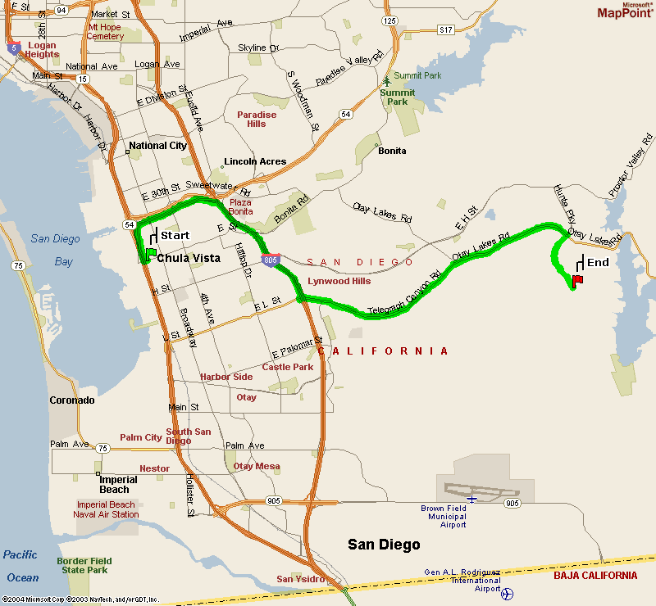

From the hotel, we will take the I-5 north to SR-54 east to the I-805 south. We will exit on Telegraph Canyon Road and head east. Telegraph Canyon Road will become Otay Lakes Road. Turn right on Wueste Road, then left onto Olympic Parkway. We will wait about 15-20 mins to take some pictures before embarking.

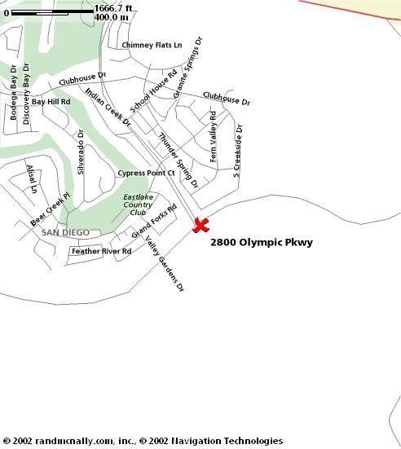

When we leave, we will be taking the following route:

- Otay Lakes Rd east to Campo Rd (SR-94) and turn left

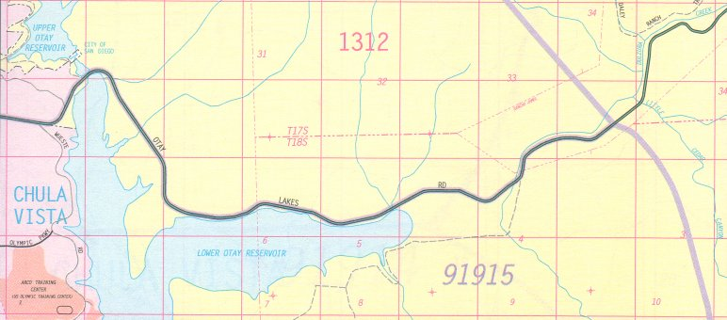

- Campo Rd north to Honey Springs Rd and turn right

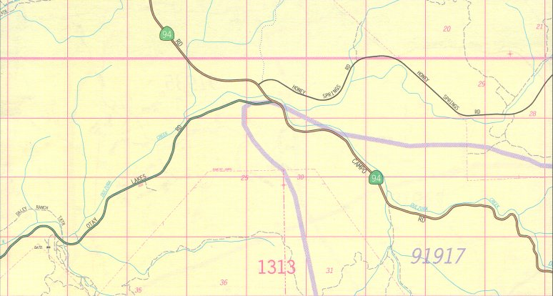

- Honey Springs Rd north to Lyons Valley Rd and turn right

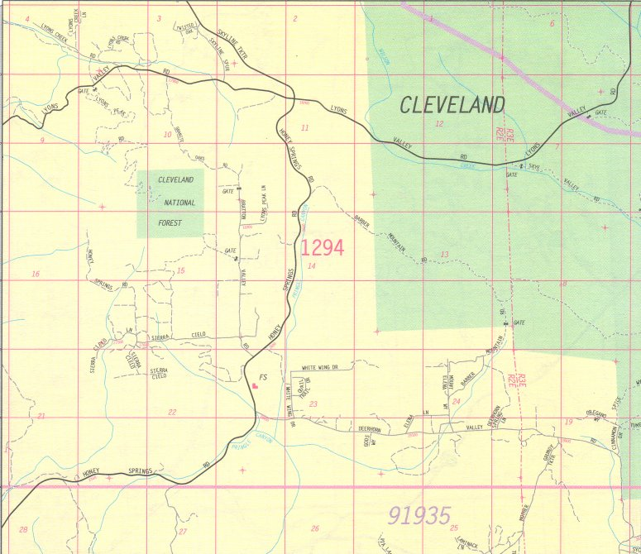

- Lyons Valley Rd to Japatul Valley Rd and turn right

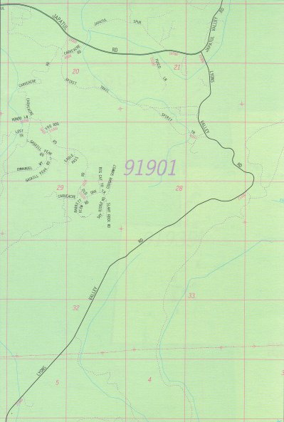
NOTE: Japatul Valley Rd crosses under I-8

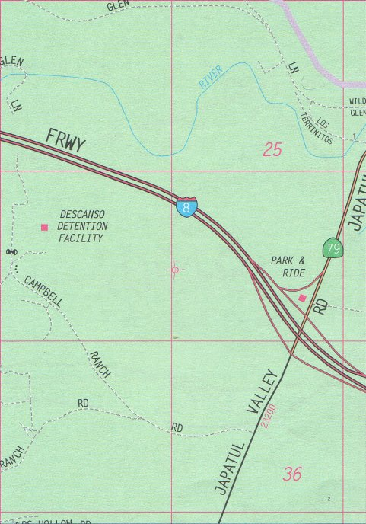

- Japatul Valley Rd becomes Cuyamaca Highway (SR-79)

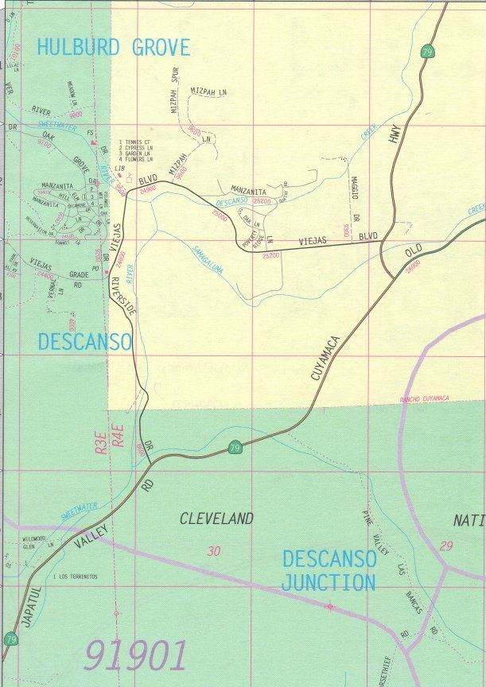

NOTE: BE CAREFUL to stay on the left side of the fork. If you do not, you will become separated from the rest of the pack.
- SR-79 to Engineers Rd and turn left

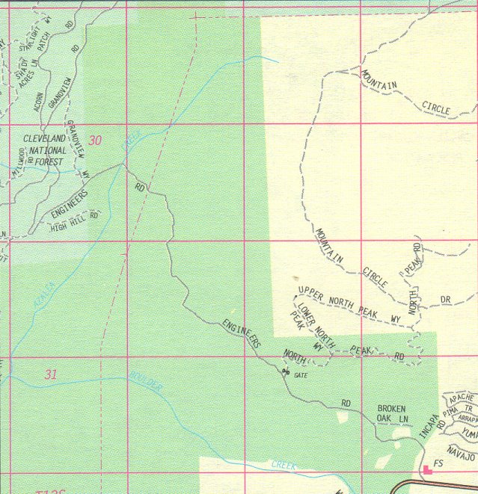

- Engineers Rd to Boulder Creek and turn right

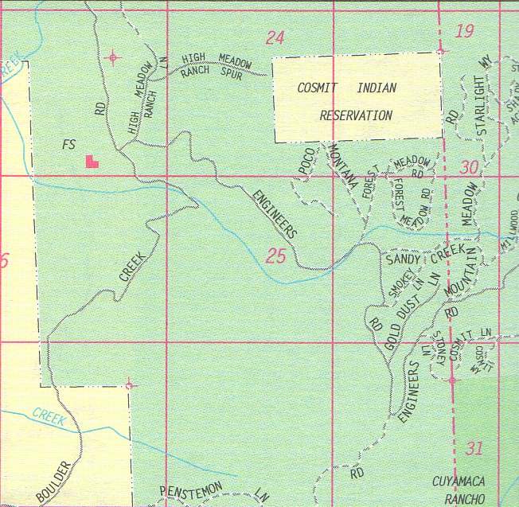

- Boulder Creek becomes Eagle Peak Road

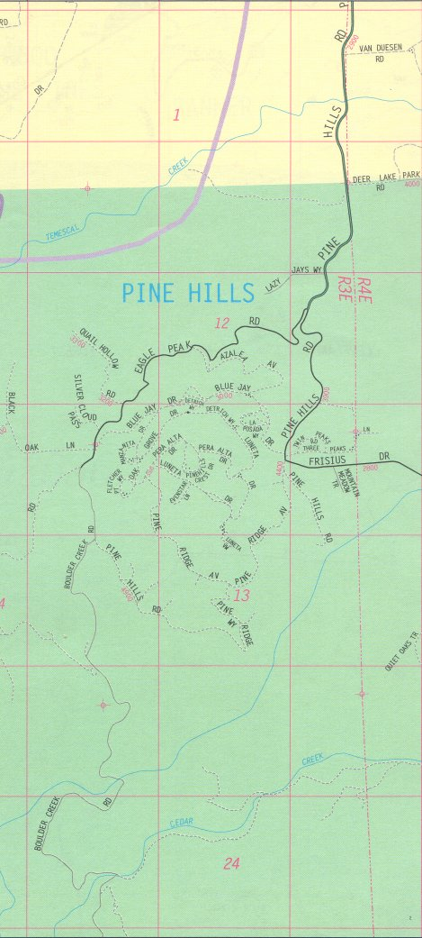

- Eagle Peak Rd to Pine Hills Rd and turn left
- Pine Hills Rd to Julian Rd (SR-78) and turn right

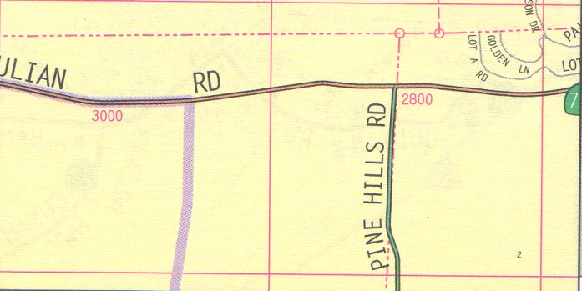

- Julian Rd to Main Street and turn right
- Main St becomes Banner Rd
- Banner Rd to Wynola Rd and turn left

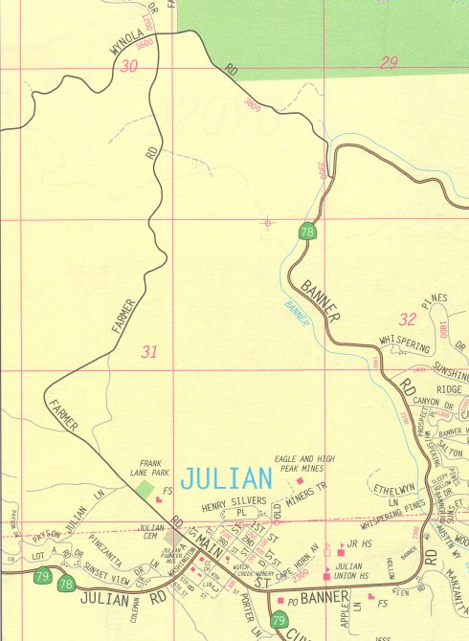

- Wynola Rd to Julian Rd (SR-78/SR-79) and turn right

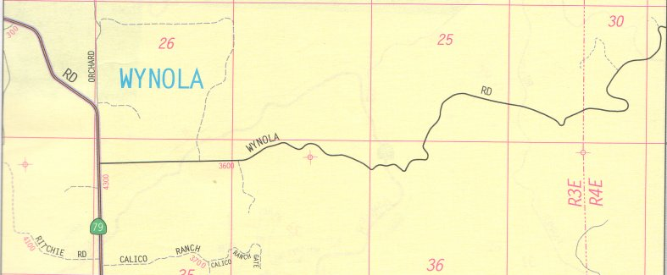

- Julian Rd to SR-78/SR-79 junction in Santa Ysabel

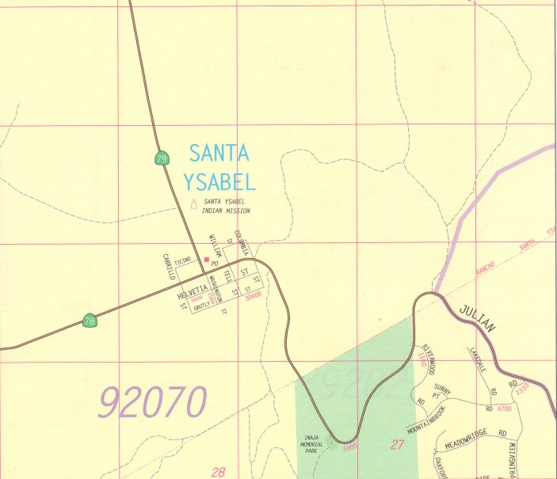

- Take SR-79 north to Pala Rd (SR-76) and turn left

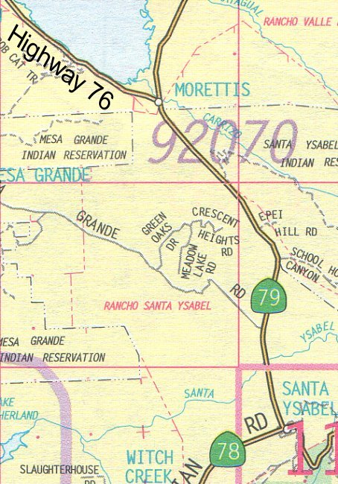

- Take SR-76 to E. Grade Road and turn right

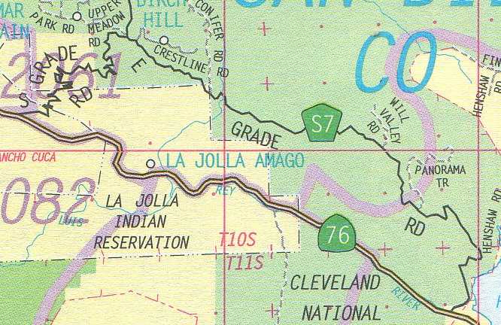

- East Grade Road becomes South Grade Road
- Take South Grade Road to Pala Rd (SR-76) and turn right

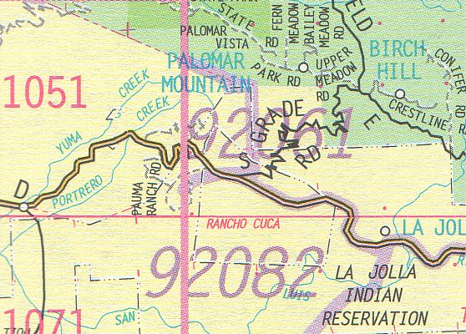

- Take Pala Road to I-15 South

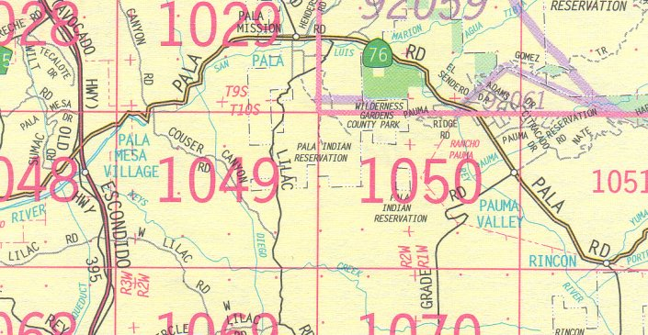

- Take I-15 South to I-5, then back to the hotel

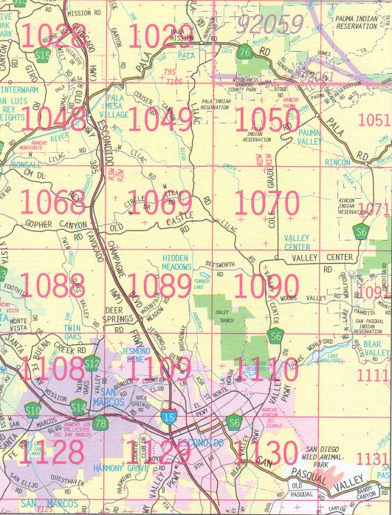

Happy motoring and we hope you enjoyed the ride!

We are planning to stop at the hotel after the drive so that we can rest a little bit and freshen up for dinner. Please drive safely on your way back to the hotel.

After the drive, I’m sure that many participants will want to freshen up for dinner, so we will be heading back to the hotel. We should reach the hotel sometime around 4:00 to 5:00pm. Plans are to reach the restaurant at 6:30pm. This year, we will be dining at Dave & Busters, located near the intersection of the I-15 and I-8 freeways.

Dave & Buster’s
2931 Camino Del Rio North
San Diego, CA 91208-1658

- Start on E Street, headed toward I-5 and head south
- Take CA-15 N toward RIVERSIDE.
- Take the I-8/JUNCTION/CAMINO DEL RIO SOUTH exit.
- Take the CAMINO DEL RIO SOUTH exit.
- Turn LEFT onto CAMINO DEL RIO S.
- Turn RIGHT onto MISSION CITY PKWY.
- Turn LEFT onto CAMINO DEL RIO N.
- Turn into shopping center and park – you’re there.

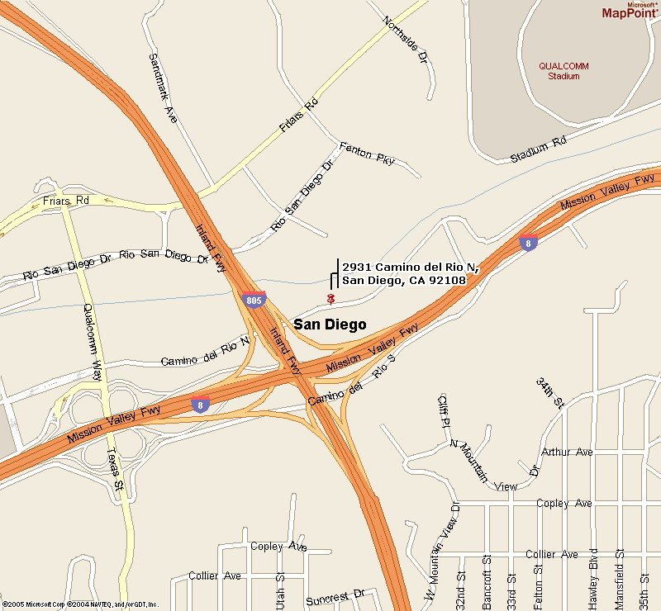

Cost of dinner should be ~$20 or so. No reservations are necessary, as there should be plenty of space available for a large party. There are games, pool, televisions and other necessities to entertain everyone. After dinner, we can visit the local grocery stores and stock up on either what we need for the BBQ or for any late night hangouts.
DAY 2 – SCPOC TOR BBQ
August 21, 2005 – 10:00am to 6:00pm

Starting Point: Fiesta Island – Mission Bay Park
San Diego, CA

Day two will be a BBQ held at Fiesta Island in Mission Bay Park, just north of Sea World.

Directions:

- From the hotel, head north on I-5
- Exit Sea World Drive and turn left
- Turn right on Mission Bay Drive
- Make a quick left onto Fiesta Island Road and look for the Probes and MX-6s

